What is Digital Sound?
Computers, as you probably already know, tend to be digital beasts. The word digital actually means ‘pertaining to the fingers or toes’, i.e. countable. Thus, a digital device deals only with discrete, countable data, unlike an analogue device, which deals with smooth, continuous data.

How, then, does a computer store the vibrating air of a sound wave, which is, after all, a continuous thing, and save it to disk? To achieve this, a process of conversion must take place. This process is known as digitisation or sampling.
When recording digitally, sound waves are picked up by the diaphragm of the microphone and converted into an (analogue) electrical signal. It is to this signal that the digitisation is applied.
Inside the recording device there is a very accurate clock, which ticks many thousands of times each second. On each tick of this internal clock, the recording device measures the strength of the signal arriving at its inputs. The strength of the signal at that time is then magnetically stored as a binary integer.
The device that performs this transition from the smooth and continuous to the discrete is called an analogue to digital converter, or ADC. The number of times each second that the internal clock of the recording device ‘ticks’ – in other words, the number of times each second that the incoming signal is measured – is called the sampling frequency. The resolution with which these measurements are carried out – which, in turn, corresponds to the length of the binary numbers used to store the data – is referred to as the bit depth of the signal. We often refer to sampled signals as being x-bit samples at y kHz, to denote them as having been digitised with this bit depth and sampling frequency.
Let’s look at an example.
Suppose the microphone has picked up a sine wave at 1 Hz:
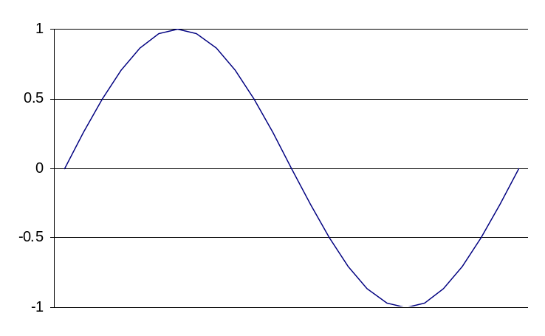
Figure 2.1 - A sine wave yesterday.
The internal clock of the recording device operates at 25 Hz. On each tick of the clock, the ADC measures the signal and converts is to digital format. The DAC operates at an 8-bit resolution, which means that each binary number that is used to store the sound data consists of some combination of 8 1’s and/or 0’s, such as 11011110. The use of 8-bit binary numbers like this gives 256 (2⁸) possible values. The result will be something like the following:
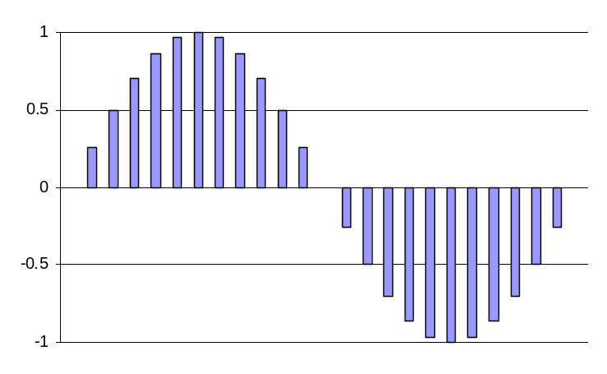
Figure 2.2 - The sine wave in digital form.
The only real difference in recording formats is in how the data are stored – for example, with DAT, the data are stored as magnetic strips along the tape, with a strong charge representing a 1, and the absence of such a charge indicating a 0. On CD, the data are stored as pitted grooves on the CD’s surface, which reflect the light from a laser – an optical medium.

What can go wrong?

Aliasing
The process of sampling is not as straightforward as it might seem. Sampling can play tricks on sound!
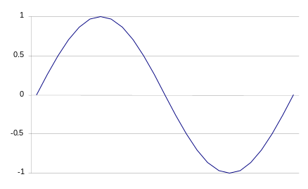
One of the most common problems that arises when recording digitally is aliasing, or foldover, so called because high frequency components create aliases (i.e. ‘fold over’) into the lower end of the frequency spectrum. This occurs when the input signal changes more quickly than the internal clock on the recording device. We demonstrate this in Figure 1.3.
result with 4 sample points
result with 2 sample points
Figure 2.3 – Aliasing.
Let's look back at our sine wave of Figure 2.1. We saw in Figure 2.2 that when the wave was sampled with a fairly high number of samples per wave cycle, that the wave could be reconstructed fairly accurately. If the wave is now sampled 4 times in this cycle (shown with the yellow stars), we can see that the wave can still be reconstructed, albeit in a very crude manner. If, however, we drop the sample rate to just two samples per wave cycle, we can see that the sampling points fall on the zero crossings. In other words, when the wave is reconstructed all that you get back is the sound of silence!
From Figure 2.3, it should be clear that provided there are more than two samples per wave cycle, the original soundwave can be accurately reconstructed. However, when there are fewer than two samples per wave period, the frequency (and possibly the timbre) of the wave changes. In fact, if the frequency of the wave being sampled is greater than half the sampling frequency:
new frequency = sampling frequency – original frequency.
This effect was first noted by Harold Nyquist, who, in 1928, noted:
For any given deformation of the received signal, the transmitted frequency range must be increased in direct proportion to the signalling speed… The conclusion is that the frequency band is directly proportional to the speed.
Thus, the essential point of the sampling theorem is that in order to be able to reconstruct a signal, the sampling frequency must be at least twice the frequency of the signal being sampled.
The highest frequency that can be produced in any digital system (i.e. half the sampling frequency) is known as the Nyquist frequency. For musical applications, this is usually set at the upper range of human hearing – about 20 kHz, meaning that the sampling frequency must be twice as much, or about 40 kHz. In practice, the sampling frequency is set slightly higher than this to compensate for the fact that the converters and associated hardware cannot perfectly reconstruct a signal near half the sampling frequency. This explains the somewhat curious choice of 44.1 kHz for the sampling rate in CD players!
There has also been some research into the range of human hearing, which suggests that humans can perceive (even though they may not actually be able to hear) frequencies in excess of 20 kHz. This has led to the use of sampling frequencies far in excess of the 44.1 kHz standard of CD – some professional DAT machines record at 24-bit, 96kHz.
Once the sampling rate has been decided upon, it is important that no rogue frequencies are passed to the ADC for conversion in case of foldback. In order to compensate for this, an anti-aliasing filter is employed to get rid of the frequency components greater than half the sampling frequency.
Quantisation noise
As we noted earlier, ADCs work to a specific resolution, determined by the bit-depth of the converter. This has important implications on the signal that is stored.
Samples are represented as integers (positive or negative whole numbers). If the input signal has a voltage that corresponds to a value between 23 and 24, say, the converter might round the value down to 23. In general, for each sample taken, the value of the sample usually differs slightly from the value of the original signal. This difference is known as the quantisation (or discretisation) error. This is demonstrated in Figure 2.4 below.

Figure 2.4 – Quantisation error. Here, the black bars show the error between the measured signal (the blue bars) and the actual signal (the curve).

Digital distortion
As with analogue recording devices, care must be taken when recording digitally to avoid distortion. However, unlike analogue distortion, digital distortion is deeply unpleasant. It arises because the signal levels arriving at the inputs of the recording device exceed its dynamic range (a measure of the loudest and quietest signals that can be recorded to the device).
Digital distortion is unlike analogue distortion because of the way that the information is stored on the recording medium. With an analogue medium, the tape (for example) suffers saturation – no more ferric oxide particles can physically fit onto the same place on tape, meaning that a louder signal will not be able to further affect the recorded signal. With digital media, on the other hand, the dynamic range is limited by the resolution (i.e. the bit depth) of the recorder – there are only a limited number of different values that can be recorded for the signal strength. Thus as the strength (i.e. the loudness) of a signal is gradually increased, eventually there will be a point at which the recording device simply runs out of numbers with which to represent the signal. When this happens, the signal switches round and moves from being extremely large and positive, to being extremely large and negative. This sudden discontinuity sounds deeply unpleasant and should be avoided at all costs!

Playback from digital recorders
In order to play back a digital audio wave (essentially just a stream of numbers), it must first be sent to a digital to analogue converter (or DAC). This is essentially just an ADC in reverse – it takes a stream of binary numbers and converts it into an analogue signal. The rate at which the numbers are sent to the DAC for conversion is controlled by an internal clock. In order for the signal to correspond exactly to the original, the clock must operate at the same frequency as the sample clock. If not, the pitch of the sound wave will be different.
On emerging from the DAC, the analogue wave is still very ‘lumpy’, due to the quantisation noise introduced by the sampling process. From here, the signal is sent to a low-pass smoothing filter to smooth the signal out. Now, the signal can be amplified and sent to a loudspeaker for playback.
Figure 2.5 below shows an overview of the whole process.
Figure 2.5 – Digital recording and playback.
sound wave
mic
preamp
LP anti-alias filter
ADC
Sample Clock
amp
preamp
LP smoothing filter
DAC
loudspeaker
Storage

Software in digital audio
Computers have many uses when it comes to composing – everything from using a notation package to produce score through to using a word processor to write program notes comes under the heading of ‘computer-assisted composition’. Here, however, we’re going to restrict ourselves to those uses that are specifically geared towards writing and producing music.
We can further subdivide this to come up with the following three categories:
- Creative – using the computer as a sketchbook or scratchpad on which to flesh out ideas and ultimately develop a composition.
- Production – using the computer to produce the finished work. This might involve recording individual parts; applying effects such as reverb, dynamics and other SFX, and mixing the tracks together to produce a final stereo track.
- Post-production – using the computer to further process the final track. This might involve normalising; equalisation, or applying complex dynamics processing.
Choosing the software for a your PC isn’t as simple as saying that we need one piece of software for each of the above categories, particularly now, when packages like Cubase offer extensive audio processing and editing functions on top of the traditional scoring and sequencing aspects. Similarly, depending on the type of compositions on which you are working, it is perfectly possible to work exclusively in audio editing packages like Sound Forge to create complete compositions.

Sequencers
MIDI devices transmit information through their MIDI interfaces only when important events, such as a key being pressed on the keyboard, occur. In order to record edit and store these events, a piece of software called a sequencer is used. Cubase is a good example of a MIDI sequencer, although it is really a whole music production suite (hence the subfix VST – Virtual Studio Technology).
Sequencers are probably best thought of as musical word processors. They allow you to record MIDI events – and note that these include but are not restricted to note events. It is possible to use Cubase, for example, to control a lighting rig, which offers a cost effective and easy-to-manage method of automating lightshows, or to control automatically a complex multi-track mix through a digital mixing desk, such as the Yamaha O1V. Once the MIDI messages have been recorded, you can alter the information to correct notes, change chords and even alter the high-level structure of the music in the same way you can delete and change typos and radically alter the structure of a piece of prose with only a few mouse clicks.
With MIDI+Audio sequencers like Cubase, a further section for integrating recorded digital audio with your compositions exists. How well it is integrated into the system will depend on the particular package, but programs like Cubase and Logic Audio do it very well indeed. In addition to recording and playing back digital audio on multiple mono and stereo tracks, such software also offers the chance to apply typical studio effects such as reverberation and compression in software. This, of course has its advantages and disadvantages: for example, while the software-only versions of effects remove the need for expensive and space-eating external hardware boxes, they do lack the tactile controls of the external boxes.

Audio editors
Audio editing software, such as Sound Forge normally include an extensive set of audio processes, tools, and effects for manipulating audio. A program of this sort generally has a feature set that is perfect for audio and broadcast production, multimedia and Internet content development, remixing, and sound design. Sound editing software works in conjunction with most Windows-compatible sound cards to create, record, and edit audio files, and can save to a number of audio and video file formats, including WAV, WMA, RM, ASF, and MP3.

Other types of software
In addition to sequencers and editors, there are a great many other types of software that can assist in the production of music:

Plug-ins
Most pro-quality audio software tends to be open-ended in nature. This allows third party developers to write their own processing software to be added at a later date. Such software are referred to as plug-ins. Plug ins range from guitar stomp-box type effects through to software versions of very high quality reverbs from pro manufacturers such as Lexicon.

Algorithmic composers
Algorithmic composition systems are computer programs that remove the need for a human composer in some aspects of the compositional process. This is something we will come back to in a later lecture, where we will look in more detail about what we mean by algorithmic composition and the philosophical implications of using computers to compose.

© Kenny McAlpine, 2002

